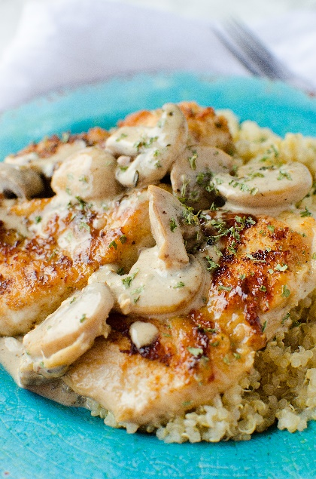
Creamy Asiago Chicken
Prep time 30 min Cook time 10 hr
4 Servings
Ingredients
1 lb. boneless skinless chicken breasts
1 tsp onion powder
1 tsp parsley
1½ cups dry white wine
2 cups mushrooms, sliced or cut in half
2 tbsp olive oil
½ cup heavy cream
2 cloves garlic, minced
½ cup flour
3 tbsp butter
½ to 1 cup shredded asiago cheese
1 tsp salt
1 tsp pepper
Directions
- Cut chicken into 3 'tender size' pieces per breast.
- Dry the chicken with a paper towel and dredge in flour, set aside.
- In a large skillet with lid, heat butter with one tablespoon of olive oil. Add the dredged chicken and sauté until golden brown on each side, roughly 4 minutes per side. Remove and set aside.
- In the same hot skillet, add the remaining olive oil, onion powder, mushrooms and garlic and sauté until mushrooms begin to brown.
- Add the white wine to skillet, scraping up all the browned bits that are at the bottom of the pan. Then add the chicken back & sprinkle with the parsley.
- Bring to a boil, reduce heat, cover and simmer for about 15 minutes.
- Remove chicken from pan once again and set to the side.
- Add the cream to the skillet and heat through. While mixing, add in the asiago cheese, stirring constantly over a low heat until cheese completely melts. Continue cooking until sauce is thickened.
- Add chicken back and heat through.
- Serve with pasta, rice, or vegetables.

Notes
Add artichoke hearts, sundried tomatoes, or capers as desired.

